When you go to classzone.com you should see the page

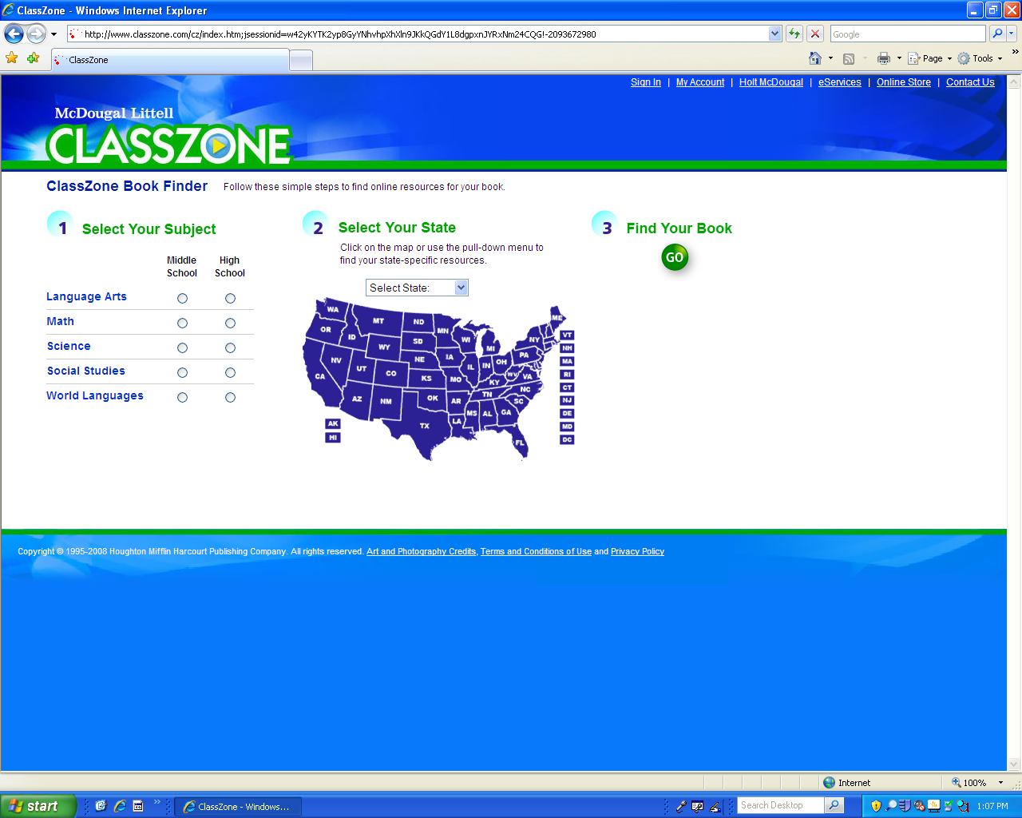

After pressing science modules button you should see the books offered below.
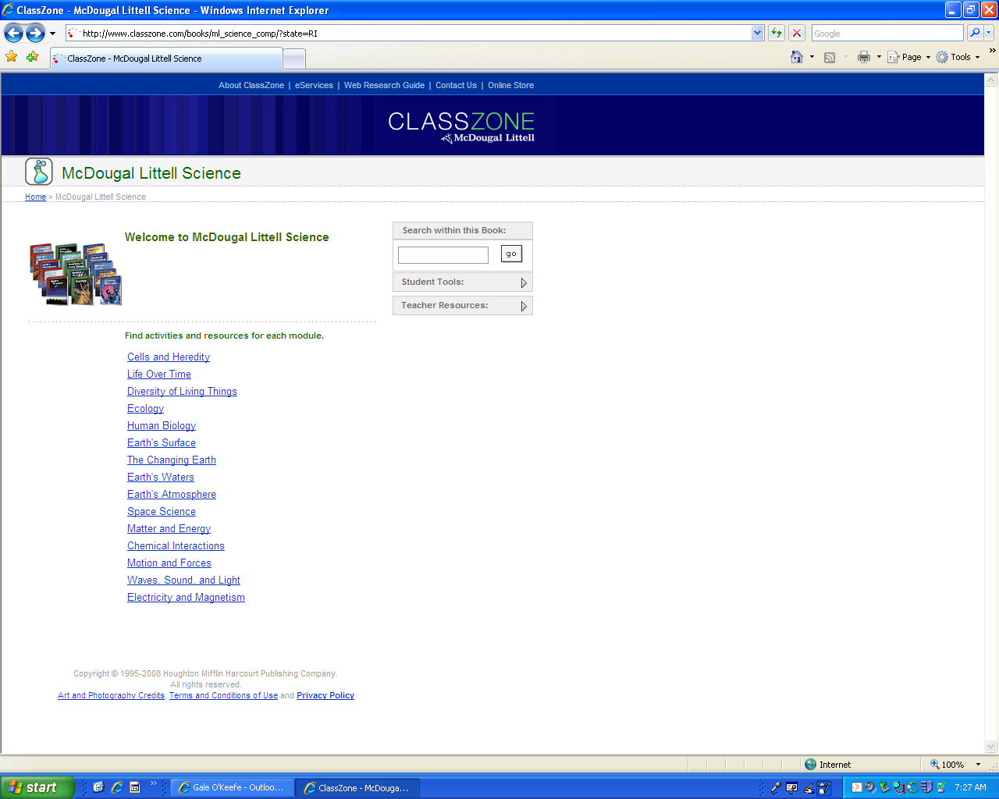

Press on the book you need to access. Example, see the red circled area for where to find the book links.

Once the link has been accessed you should see the page below, which offers types of resources such as Simulations, Visualizations and Math Tutorials.

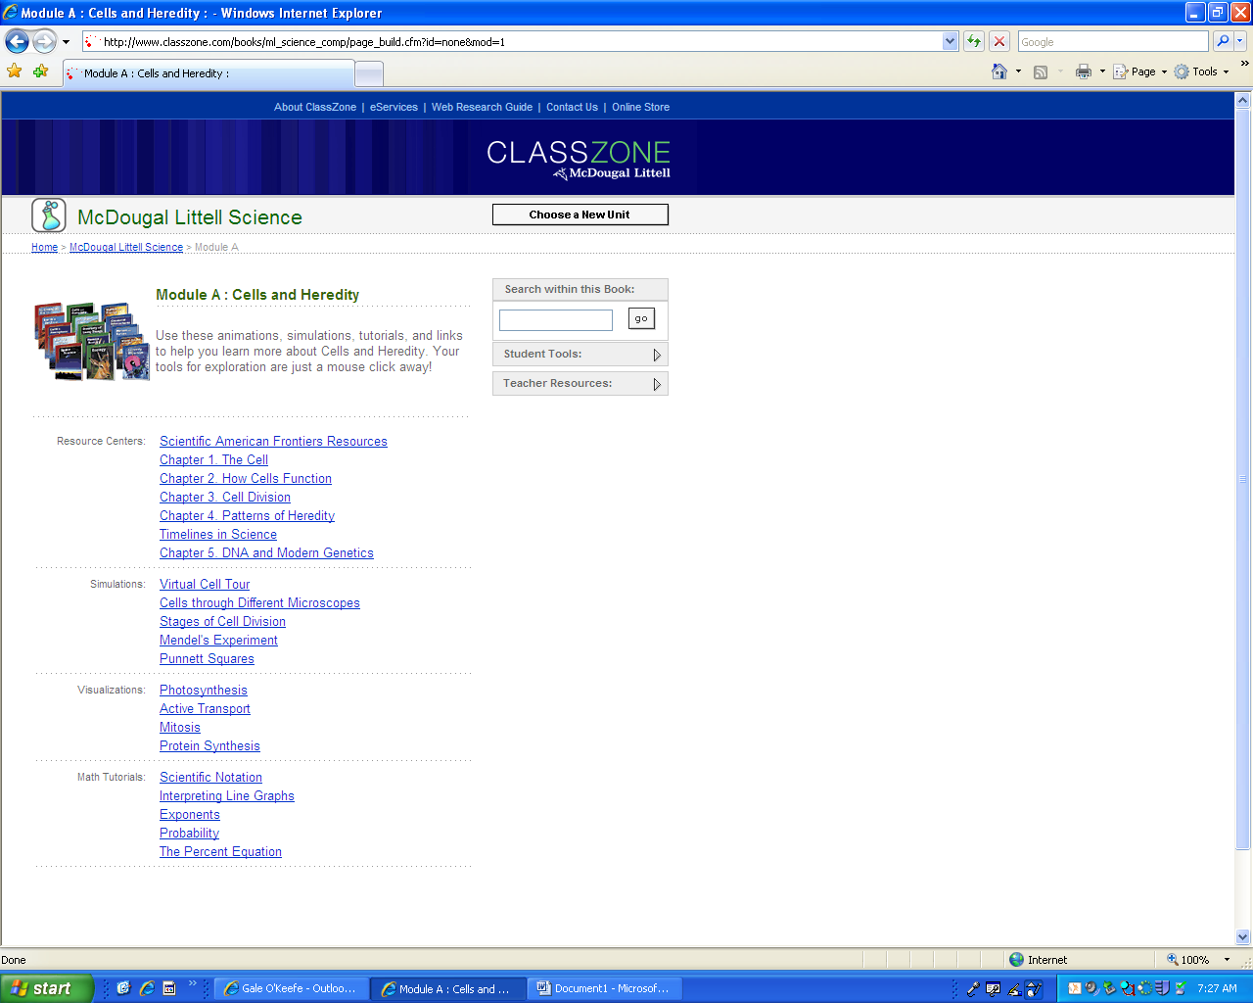

Press (see the red circled area) the chapter you are interested in and it will take you to the page you can see below.

If you expected to see the chapter in the book please press eServices (see red circled area below) and it will take you to the link on the next page.
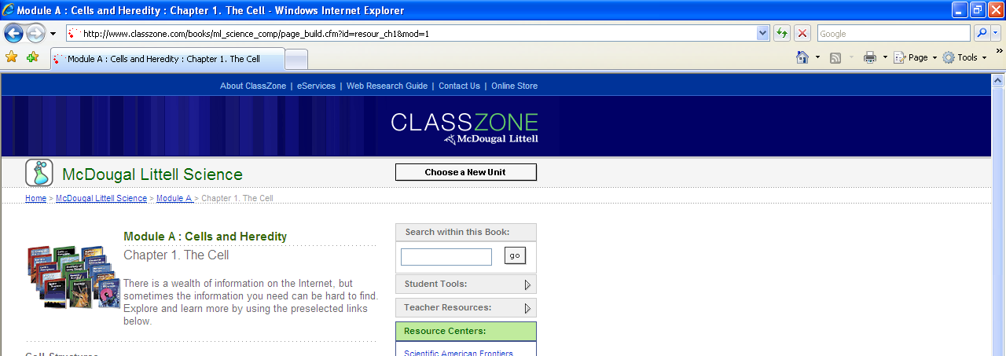

This is the page that will allow you to access the on-line text book. If your child has signed up for the book you will need to input their username and password. If your student has not registered for the book please see the directions on how to register for the science book on mrsokeefe.weebly.com


